# Basic Operational Amplifiers (Op Amps)

Written by Mark Webster and ??

**Summary**

Learn to build simple electronic circuits with Op Amps.

## Introduction

Operational amplifiers (op amps) are integrated circuits containing many transistors, and that function as an analog amplifier.

<https://en.wikipedia.org/wiki/Operational_amplifier>

Op amps are high gain, high input impedance, and low current draw. Op amps can produce large voltage gains but cannot drive a high power device such as a speaker.

## 741 and 324

### LM741

One of the oldest, least expensive, and most stable op amp is the 741. Sometimes several 741 chips are packaged into one chip, such as with the LM747. The 741 is less prone to oscillation and burn-out than other chip designs. However, the 741 is lower bandwidth and higher current drain than other chips.

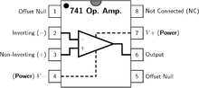 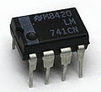 (replace)

### LM324N

When a circuit requires multiple op amps, an inexpensive and compact alternative is the LM324 quad op amp. It is low current draw and works well with single power supply circuits.

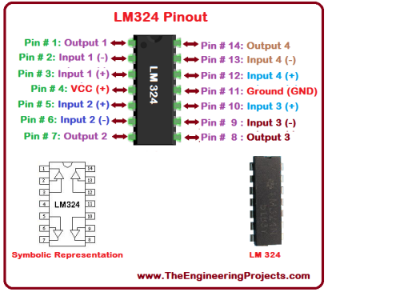(replace)

## Applications

There are many, many applications of op amps developed by clever engineers and hobbyists over the decades since 1967. This workshop will only cover a few possibilities.

### Virtual Ground

Often analog circuits or op amp circuits require a dual polarity power supply, such as +12 V and -12 V. This is inconvenient with battery powered circuits, or with circuits that connect to digital devices which are often use single polarity power. Sometimes two batteries are used in series, with the ground between the two batteries, but that too is inconvenient when just one 9V battery is available.

The trick is to use a resistor divider and then an op amp as a buffer to create a virtual ground halfway between Vcc and ground.

#### Exercise 1: Virtual Ground

On a breadboard combine a 9V battery, a capacitor, two equal resistors, a 1K load protection resistor and a 741 op amp (or one of a LM324) to create a virtual ground.

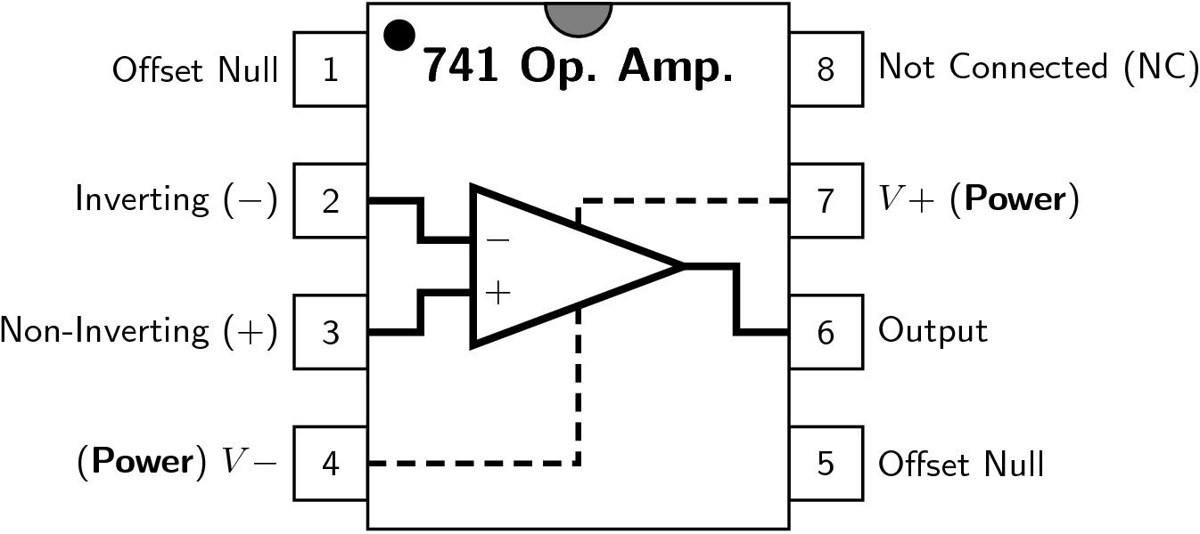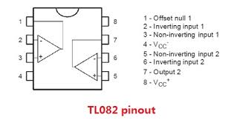

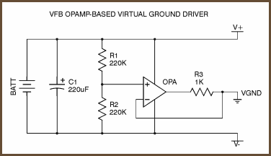 (replace)

The 1K resistor is optional.

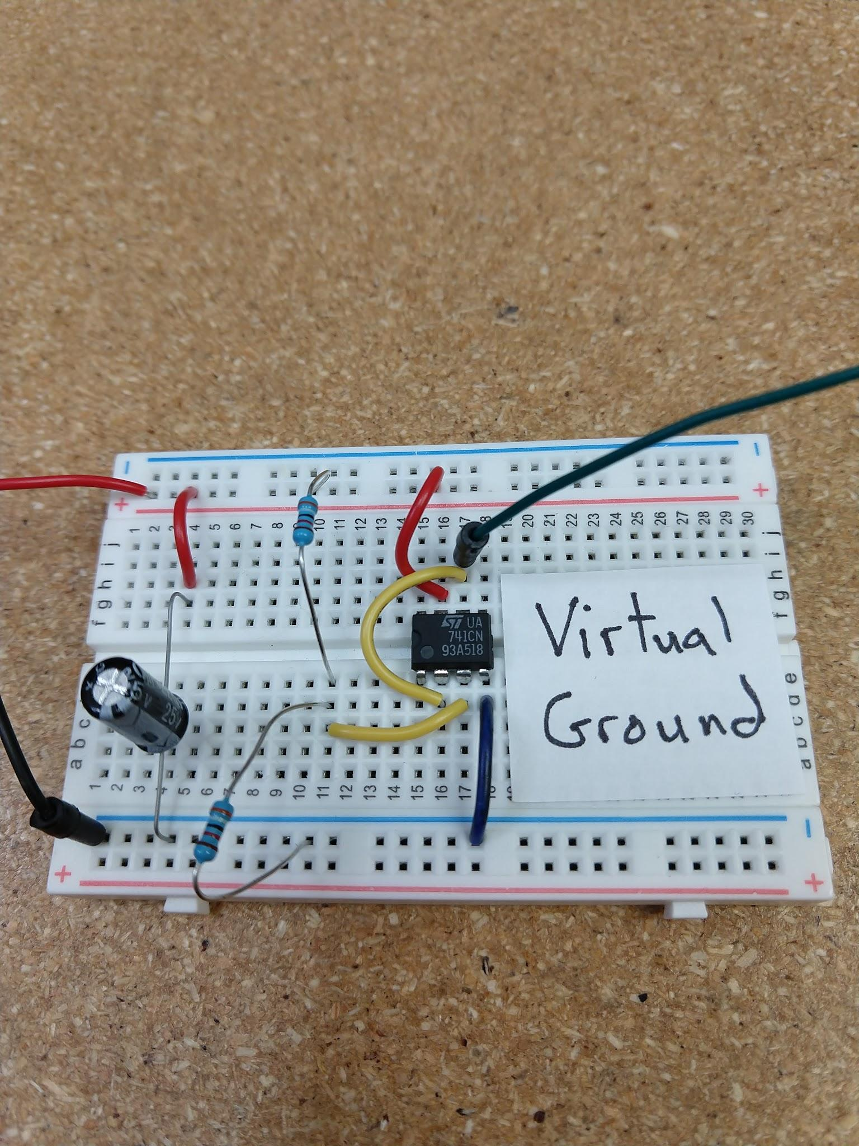

### Comparator

Sometimes all that is desired is to trigger an output when a voltage level drops below or rises above some value. This could be used to water a plant, turn on a night light, indicate low battery, or trigger an alarm. An op amp is used compare two voltages on its differential input and swing fully high or low on the output.

<https://en.wikipedia.org/wiki/Comparator>

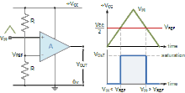

#### Exercise 2: Comparator

On a breadboard build a circuit with a 741 and a potentiometer to turn on an LED.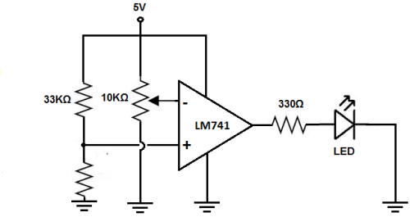

(replace)

### Inverting Amp

When a voltage gain is needed and it doesn’t matter if the output signal is 180 degrees out of phase with the input, the simplest op amp circuit is an inverting amplifier.

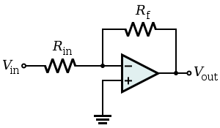 (replace)

Gain is . Notice the negative sign in front of the gain. This indicates the voltage is reversed relative to ground.

#### Exercise 3: Inverting Amp

Take a low voltage signal from a function generator (use a voltage divider) and feed the signal into an inverting op amp circuit. Look at the result on an oscilloscope.

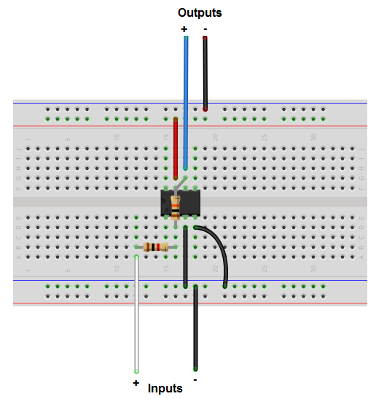

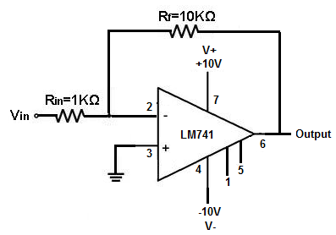 (replace)

### Non-inverting Amp

Amplifies the input signal but does not invert.

#### Exercise 4: Non-inverting amp

Use a function generator, oscilloscope, and a 741 (or . Creating a virtual ground may be e

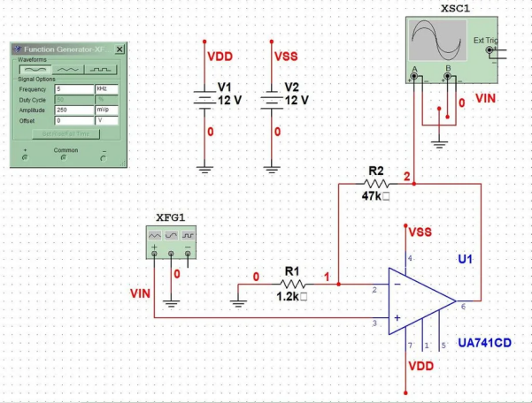

(replace)

The voltage gain of a non-inverting amplifier is:

### Differential Amp

To reject noise that is common between two inputs, and only view the difference between the inputs, a differential amplifier circuit is used. This circuit is sometimes called a subtracting amplifier.

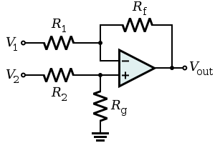 (replace)

When R1 = R2, and Rf = Rg, then the gain is

#### Exercise 5: Differential Amp

Set up a high gain differential amp with two leads. Hold one lead in the left hand, the other in the right hand. The electrical signal from the beating heart (assuming the user is not a zombie) should be visible on an oscilloscope.

### Summing Amplifier

To add two signals without one changing voltage distorting the other, a summing amplifier is used. Sometimes this is called an adder circuit.

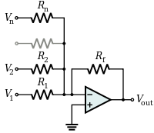 (replace)



#### Exercise 6: Summing amp

Use two sine wave generators and combine the two signals using a summing op amp circuit. Look at the output on an oscilloscope.

Alternately, use two DC inputs and look at the DC voltage of the output.

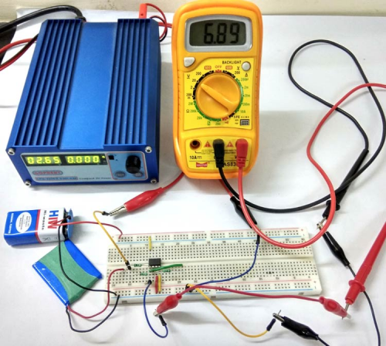 (replace)

### Differentiator Circuit

Op amps were developed originally for analog computers, hence there are circuits that do calculus.

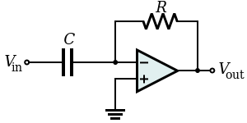 (replace)

where Vin and Vout are functions of time.

#### Exercise 7: Differentiator

Take a square wave or triangle wave from a function generator. Feed it into a differentiator op amp circuit and look at the output on an oscilloscope.

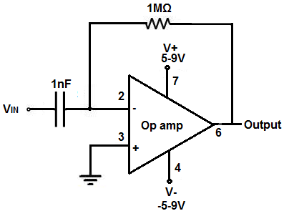 (replace)

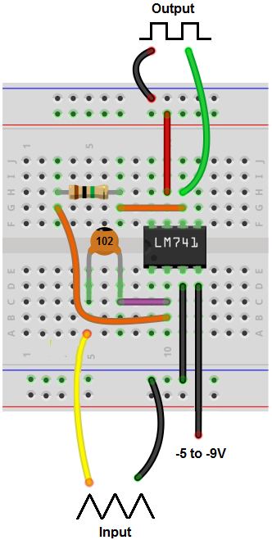 (replace)